Editorial: Quincy mayor must resign today

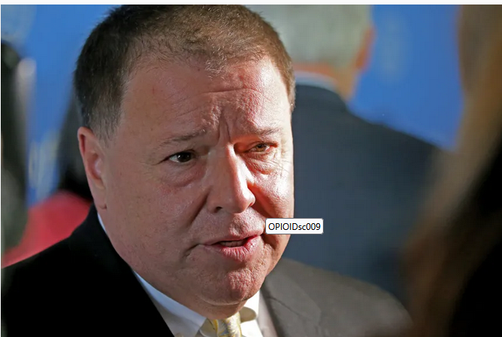
Quincy Mayor Thomas Koch (Herald file)

By Boston Herald editorial staff
UPDATED: September 26, 2025 at 7:59 AM EDT
Attorney Mitchell Garabedian has seen the “ugly” side of the Catholic church sexual abuse crisis in “thousands of pages” of legal documents. Quincy Mayor Thomas Koch, clearly, has not.
Koch said on Dan Rea’s “Nightside” radio show on WBZ Monday night that the scandal was “mostly homosexual issues, not pedophilia.”
That is misinformation that cannot go unchallenged. But the Democratic mayor doubled down on his insane lack of empathy.
“Pedophilia is a younger age than a teenager,” Koch said, failing to note that the law recognizes 18 years old as adulthood. In case he forgets, his sworn duty is to uphold that law — and he’s also the chairman of the Quincy School Committee and an MBTA board member. He is so off base it’s beyond irresponsible.
On the radio show, Koch quickly pivoted to bashing the “secular media” for not reporting on others outside the church who commit sexual crimes against minors.
Also, a gross falsehood.
Koch issued a statement Thursday saying: “I publicly apologized … directly to our gay community and our schools community for my ill-thought remarks. … I was caught off-guard by the question and tried to make a larger point about sexual abuse across all segments of society.”
He added, “I know better and will do better.”
We called attorney Mitchell Garabedian. He has devoted his career to representing victims of sexual abuse by priests. We’d argue that Mayor Koch needs to give this attorney a call, too.
“I’ve reviewed thousands of documents,” Garabedian said, “and the church sexual abuse crisis is a pedophile problem. Period!”
After reviewing those court records, anyone with an ounce of humanity would come away furious at the criminal cover-up perpetrated against innocent young children by priests. To suggest anything different goes against what every decent person believes.
Mayor Koch needs to apologize to loved ones who lost abuse victims to suicide. He should also seek forgiveness from all the sexual abuse victims who have suffered and continue to suffer.
Then, Mayor Koch should resign and Gov. Maura Healey should drop him from the MBTA board.
On a basic human level, the mayor should be ashamed of himself. The crisis in the Catholic church will only truly heal when everyone acknowledges the institutional cancer that metastasized.
Mayor Koch is only feeding into the doubters and deniers who fail to recognize that sometimes the truth hurts, but what’s the other option? Lies?
Children need examples to live by so they can dare to stand against what’s wrong in our world. Courage is a skill, and Mayor Koch has eroded that, but voters should not let him.
Anyone under 18 is still a child. That’s the law. We’d argue that young adults still need mentors, and that’s what is missing in our society today. Quincy Mayor Thomas Koch does not understand this, and he needs to go.
The Quincy City Council last year approved a salary hike that would pay Koch $285,000 a year. That pay hike is before voters and not only should it be rejected, they should call for a special election to boot Mayor Koch from office.
Go ahead and blame the press. We are happy to tell the truth and nothing but the truth, so help us God.
Originally Published: September 26, 2025 at 4:12 AM EDT

